Dashboard Design

Date | 19-08-2026
Team ID | MCA
Project Name | Smartphone Usage, Digital Addiction & Well-Being Analytics
Maximum Marks | 5 Marks

The dashboard for Smartphone Usage, Digital Addiction & Well-Being Analytics is designed to present smartphone usage, digital addiction, and well-being information in a clear and interactive manner. Power BI is used to create visualizations, filters, slicers, and interactive elements that help users understand important patterns in the data.
Activity 1: Interactive and visually appealing dashboards
The dashboard for Smartphone Usage, Digital Addiction & Well-Being Analytics is designed to present smartphone usage, digital addiction, and well-being information in a clear and interactive manner. Power BI is used to create visualizations, filters, slicers, and interactive elements that help users understand important patterns in the data.
- Clear and Intuitive Layout
- Use Appropriate Visualizations
- Colour and Theming
- Interactive Filters and Slicers
- Drill-Down Capabilities
- Responsive Design
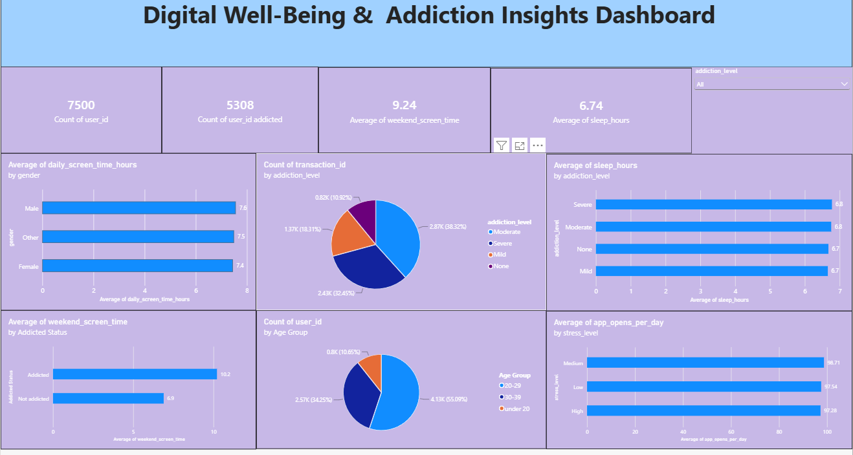
- Major Outcomes from the Smartphone Usage, Digital Addiction & Well-Being Dashboard:

- Total Users: The dashboard records 7,500 users, providing the overall user population analyzed in the project.

- Weekend Screen Time: The average weekend screen time is 9.24 hours, indicating substantial smartphone usage during weekends in the analyzed dataset.

- Sleep Duration: The overall average sleep duration shown on the dashboard is 6.74 hours.

- Addiction-Level Distribution: The dashboard shows 2.87K users in the Moderate addiction category (38.32%), 2.43K in Severe (32.45%), 1.37K in Mild (18.31%), and 0.82K in None (10.92%).

- Age-Group Distribution: The dashboard shows approximately 3.69K users aged 20–29 (49.23%), 2.57K aged 30–39 (34.29%), and 1.24K under 20 (16.53%).

- Screen Time by Gender: Average daily screen time is approximately 7.6 hours for Male, 7.5 hours for Other, and 7.4 hours for Female users.

- Weekend Screen Time by Addiction Status: The dashboard shows approximately 10.2 hours for Addicted users and approximately 7.0 hours for Not addicted users.

